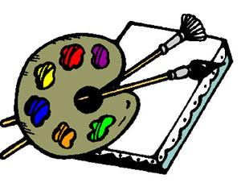
Artist
Name:
Book:
Pages:
Your job is to draw a picture relating to this reading. It can be a sketch, cartoon, diagram, flow chart, map, etc. It can be of a scene, character, setting, or idea, as long as it relates to this section of the book.
- Draw your illustration on the back of this page.
- Use pencil and/or colored pencils.
- Your drawing must show evidence of effort! No stick figures.
- In the space below, explain why you chose to draw your picture. Explain the importance of the picture to the chapter or the novel as a whole.
____________________________________________________________________________________________________________________________________________________________________________________________________________________________________________________________________________________________________________________________________________________________________________________
*When the discussion director says it’s your turn, show your illustration without any explanation. Ask each person to comment or ask a question regarding your drawing. After everyone has responded, explain your picture and answer any questions regarding your picture.

