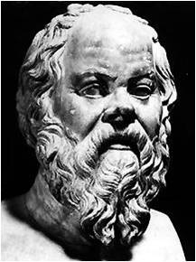
Team 5 History Students & a Socratic Seminar
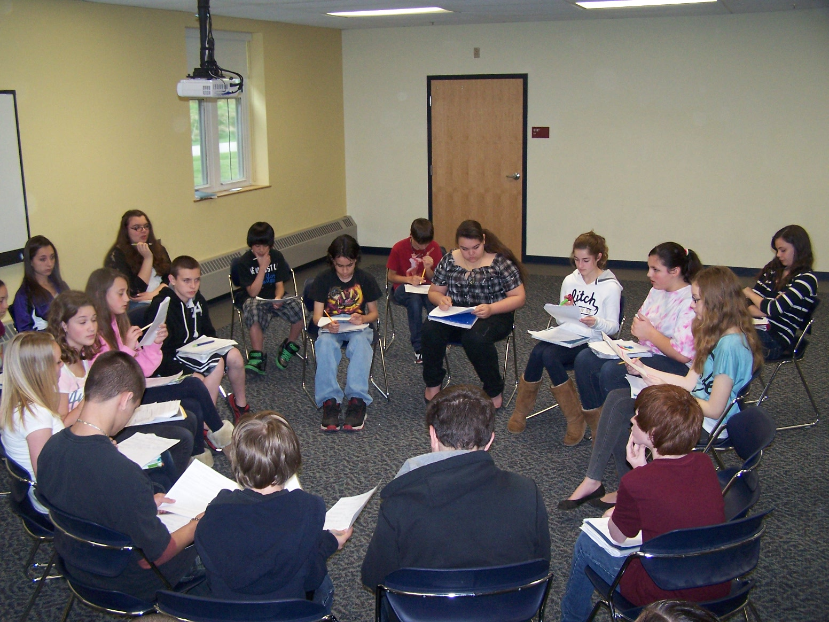
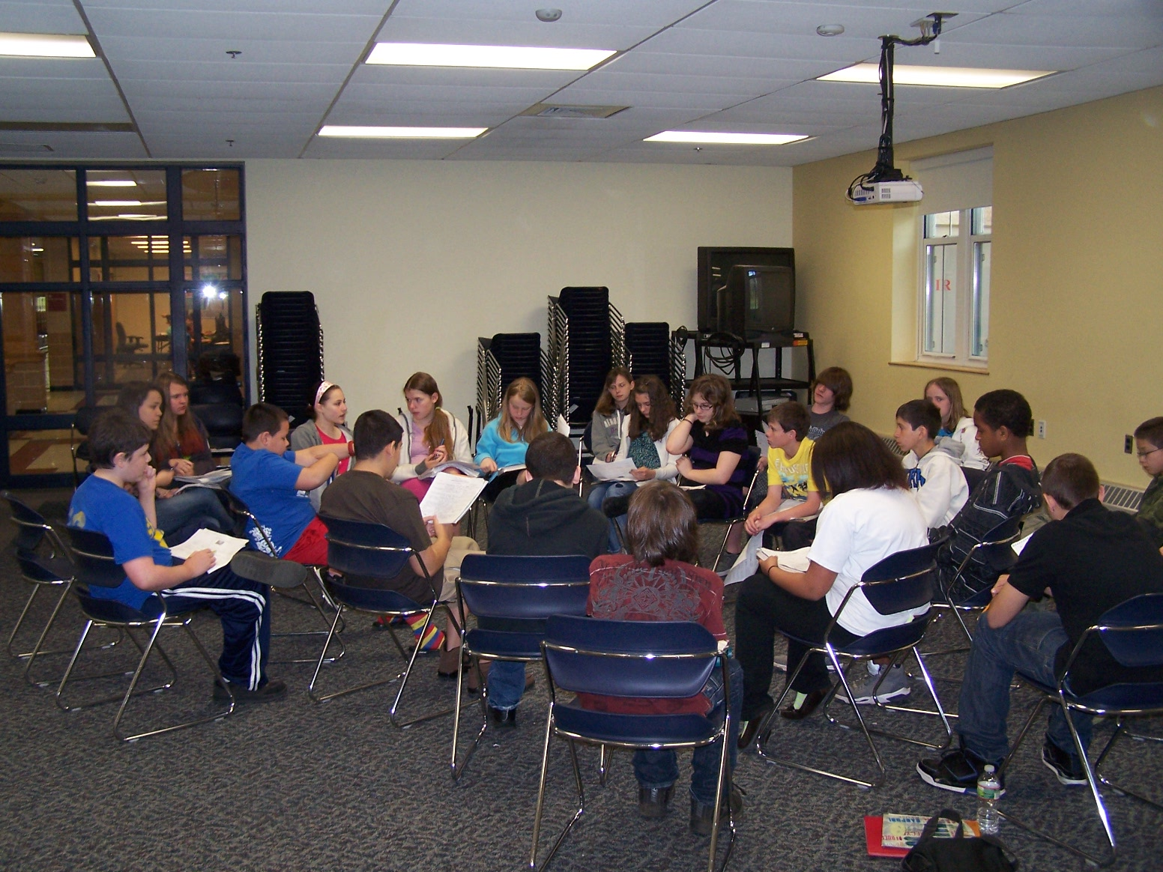

Team 5 history students conducted a Socratic seminar on April 27, 2012. A Socratic seminar is a way of teaching, founded by the Greek philosopher Socrates. Socrates developed the Theory of Knowledge, which says that the surest way to attain reliable knowledge is by having disciplined conversation. Socrates believed that students learn best by asking questions. The teacher will facilitate the discussion, but not lead the discussion. Socratic Seminars help us engage a text in class. The thought process is when we work together to understand a text it will help everyone’s understanding.
For three days, students worked in groups with primary source documents written by George Washington. The class was divided into two groups. One group focused on the Whiskey Rebellion and the other on the Proclamation of Neutrality. Each student had to complete a graphic organizer answering several essential questions and then create two questions of their own.
On the day of the seminar, the classroom was arranged in two concentric circles. When students were in the inner-circle they were the only participants in the discussion. If a student was in the outer-circle he/she scored a partner assigned to that student. After about 20 minutes of discussion, the circles exchange. The first group in the inner circle discussed the Whiskey Rebellion and the second group discussed neutrality.

How does the discussion work in a seminar?
The seminar is to serve as a discussion, not a lecture. Just like in a casual conversation, this is a conversation that begins naturally. There are a couple of guidelines to follow:
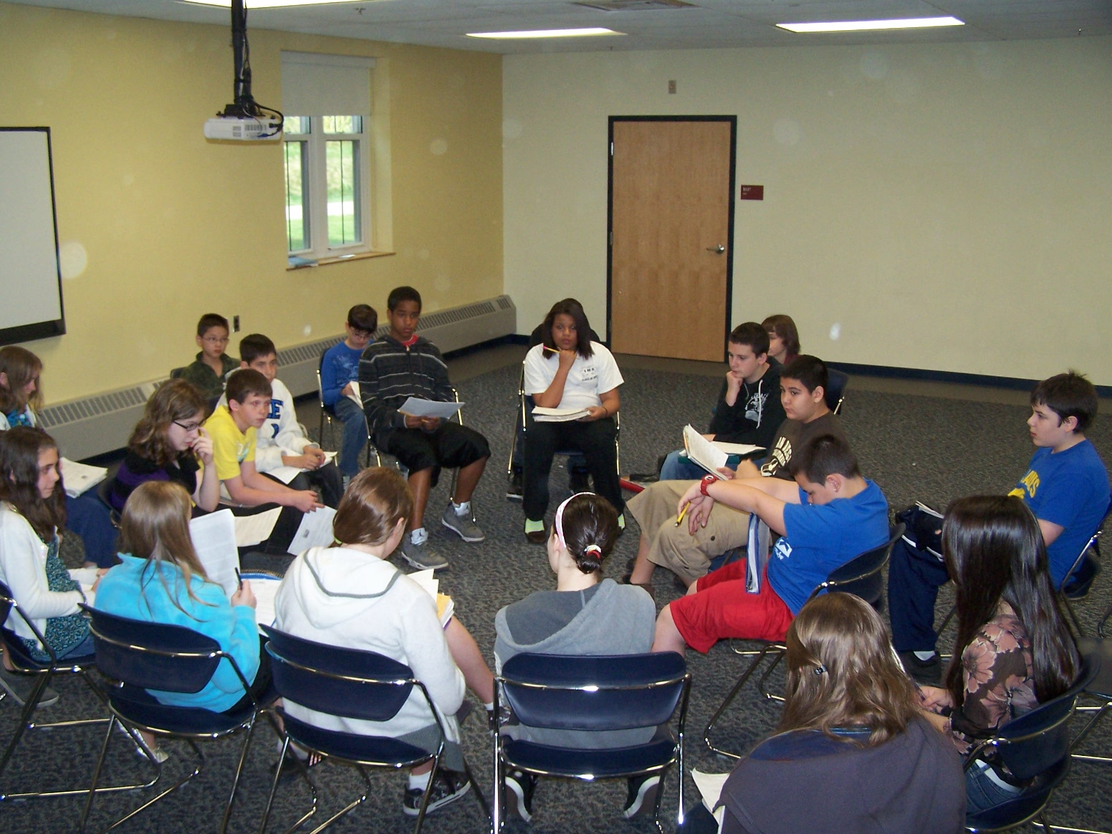
- Only Inner Circle students engage in the discussions.
- Please listen and look at each other when you speak.
- One person speaks at a time. A ball of string will be used as the speaking object.
- Each person will have a chance to ask a question and everyone has a chance to respond.
- Respond to the person who asks the question.
- Use evidence from the text to support yourself.
- Each person should have a copy of the text.
In order for a Socratic Seminar to be successful, the students must display a high level of maturity and preparation. Team 5 students did a great job in each and every period. They held adult conversations about some very difficult text and made that day a fulfilling one.
