Word Detective 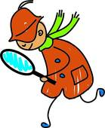
Name:
Book:
Pages: Meeting #:
Your job is to search for the most important words, phrases and ideas from today’s reading assignment. Consider unfamiliar words, words used in a different way, and central ideas from the reading. You must have at least 4 words, phrases or ideas. Then explain why it was important; does it show something about the character, theme, etc.?
Word/Phrase/Idea | Page(s) | Why I Chose This

